TRANSMISSION LINES & WAVEGUIDES – ECA1501

EXPERIMENT – 1
Estimation of Characteristic Impedance (Z₀) and Propagation Constant (γ) of a Transmission Line

Name | Karan M | Reg. No. | 192412062
Date | 10/10/2026 | Experiment No. | 1

AIM
To investigate the significance of the characteristic impedance (Z₀) and propagation constant (γ) of a transmission line using its primary constants R, L, G and C, and to study the effect of resistance, inductance, frequency and capacitance.

SOFTWARE REQUIRED
SCILAB Version 6.1.1

THEORY / FORMULAE
Characteristic impedance:
Z₀ = √[(R + jωL)/(G + jωC)]
Propagation constant:
γ = √[(R + jωL)(G + jωC)] = α + jβ
where α is the attenuation constant in neper/km, β is the phase constant in radians/km, and ω = 2πf.

PROCEDURE
  - Open SCILAB software.
  - Open a new file.
  - Enter the required values of R, L, G, C and frequency.
  - Type and execute the SCILAB program.
  - Record Z₀, α and β.
  - Repeat the calculation for each variation specified in the test cases.

TEST CASE 1 – BASIC CALCULATION
Investigate Z₀ and γ for the given transmission-line primary constants.

Parameter | Value | Unit
R | 10 | Ω/km
L | 3.5 | mH/km
C | 8 | µF/km
G | 4 | µmho/km
f | 2 | kHz

TEST CASE 1 – RESULT TABLE

S.No. | Input | Z₀ (Ω) | α (neper/km) | β (rad/km) | Status
1 | R=10, L=3 mH,  C=16 µF, G=4 µmho, f=2 kHz | 14 − j2 | 0.3621 | 2.7769 | Matches attached SCILAB output

TEST CASE 2 – EFFECT OF RESISTANCE AND INDUCTANCE
At f = 2.5 kHz, the resistance is varied from 10 Ω to 50 Ω in steps of 10 Ω while the other constants are kept fixed. The inductance is varied from 3.5 mH to 11.5 mH with R, G and C constant, as specified in the lab manual.
- Variable Resistance (R): L = 3.5 mH/km, C = 8 µF/km, G = 4 µmho/km, f = 2.5 kHz

S.No. | R (Ω/km) | Z₀ (Ω) –  Simulation* | α – Simulation* | β – Simulation* | α – Theory | β – Theory
1 | 10 | 21.00 − j1.89 | 0.2381 | 2.6392 | 0.2381 | 2.6392
2 | 20 | 21.25 − j3.74 | 0.4707 | 2.6702 | 0.4707 | 2.6702
3 | 30 | 21.63 − j5.52 | 0.6935 | 2.7184 | 0.6935 | 2.7184
4 | 40 | 22.12 − j7.19 | 0.9042 | 2.7796 | 0.9042 | 2.7796
5 | 50 | 22.68 − j8.77 | 1.1023 | 2.8502 | 1.1023 | 2.8502

- Variable Inductance (L): R = 10 Ω/km, C = 8 µF/km, G = 4 µmho/km, f = 2.5 kHz

S.No. | L (mH/km) | Z₀ (Ω) –  Simulation* | α – Simulation* | β – Simulation* | α – Theory | β – Theory
1 | 3.5 | 21.00 − j1.89 | 0.2381 | 2.6392 | 0.2381 | 2.6392
2 | 6.0 | 27.42 − j1.45 | 0.1824 | 3.4463 | 0.1824 | 3.4463
3 | 8.5 | 32.62 − j1.22 | 0.1534 | 4.0990 | 0.1534 | 4.0990
4 | 11.0 | 37.10 − j1.07 | 0.1349 | 4.6617 | 0.1349 | 4.6617

TEST CASE 3 – EFFECT OF FREQUENCY AND CAPACITANCE
The frequency is varied from 2 kHz to 10 kHz in steps of 2 kHz with L, R, G and C constant. Capacitance is varied from 8 µF to 16 µF in steps of 2 µF with R, L and G constant, as specified in the lab manual.
- Variable Frequency (f): R = 10 Ω/km, L = 3.5 mH/km, C = 8 µF/km, G = 4 µmho/km

S.No. | f (kHz) | Z₀ (Ω) –  Simulation* | α – Simulation* | β – Simulation* | α – Theory | β – Theory
1 | 2 | 21.05 − j2.36 | 0.2376 | 2.1161 | 0.2376 | 2.1161
2 | 4 | 20.95 − j1.19 | 0.2387 | 4.2123 | 0.2387 | 4.2123
3 | 6 | 20.93 − j0.79 | 0.2389 | 6.3128 | 0.2389 | 6.3128
4 | 8 | 20.92 − j0.59 | 0.2390 | 8.4144 | 0.2390 | 8.4144
5 | 10 | 20.92 − j0.48 | 0.2390 | 10.5165 | 0.2390 | 10.5165

- Variable Capacitance (C): R = 10 Ω/km, L = 3.5 mH/km, G = 4 µmho/km, f = 2 kHz

S.No. | C (µF/km) | Z₀ (Ω) –  Simulation* | α – Simulation* | β – Simulation* | α – Theory | β – Theory
1 | 8 | 21.05 − j2.36 | 0.2376 | 2.1161 | 0.2376 | 2.1161
2 | 10 | 18.83 − j2.11 | 0.2656 | 2.3659 | 0.2656 | 2.3659
3 | 12 | 17.19 − j1.93 | 0.2910 | 2.5917 | 0.2910 | 2.5917
4 | 14 | 15.91 − j1.79 | 0.3143 | 2.7994 | 0.3143 | 2.7994
5 | 16 | 14.88 − j1.67 | 0.3360 | 2.9927 | 0.3360 | 2.9927

SCILAB PROGRAM
clear; clc;
R=10;L=0.003;f=2*10^3;G=4*(10^-6);C=16*(10^-6);
w=2*%pi*f;
Z=R+(%i*w*L);
Y=G+(%i*w*C);
Zo=sqrt(Z/Y);
C=round(real(Zo));
D=round(imag(Zo));
printf('-Zo = %f + j(%f)ohms\n',C,D); P=sqrt(Z*Y);
a=real(P); a1=round(a*10000)/10000;
printf('-Attenuation constant a = %f neper/km\n',a1); b=imag(P);
b1=round(b*10000)/10000;
printf('-Phase constant b = %f radians/km',b1);

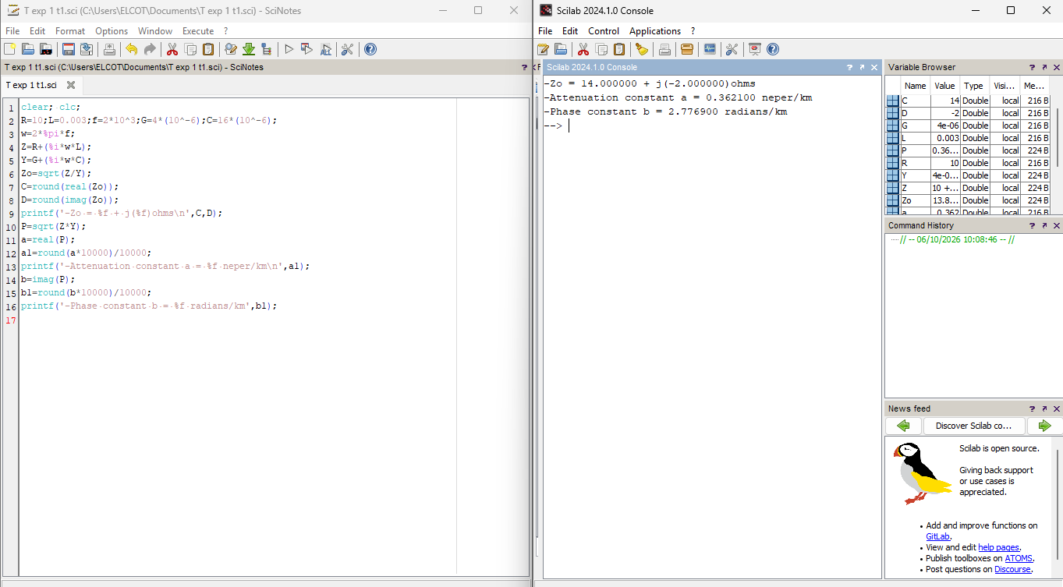

RESULTS
Test Case 1: The attached SCILAB output gives Z₀ = 14 − j2 Ω, α = 0.3621 neper/km and β = 2.7769 radians/km.
Test Case 2: The effect of resistance and inductance on Z₀, α and β was evaluated for the ranges specified in the manual. Test Case 3: The effect of frequency and capacitance on Z₀, α and β was evaluated for the ranges specified in the manual.

